**North South University**

**Department of Electrical and Computer Engineering**

**CSE 215L: Programming Language II Lab**

**Lab** – **7: Class & Object**

**Objective:**

* To learn about class and objects
* To learn to implement a class using UML

**Task:**

Implement the following classes, each on a separate file:

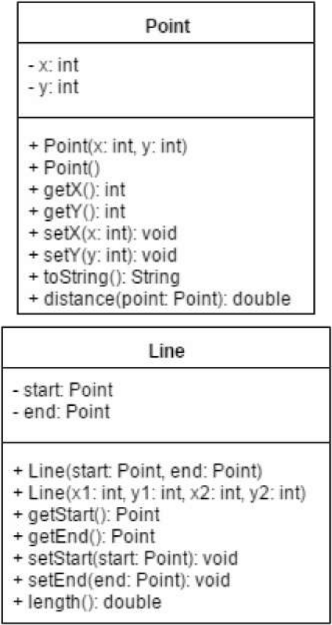

Now create a Line object and invoke the length() method.